Background Information

The American Revolution was shaped not just by British policies or colonists, but also by enslaved Africans and people of African descent.
Across New England, enslaved Africans worked side by side white workers. Enslaved women worked in close proximity to their enslavers in colonial homes. In the years leading up to war, enslaved people listened as colonists argued over their rights to liberty from an oppressive government. They watched as colonists protested and resisted British laws. And they understood how the ideas of freedom and equality applied to their own lives.
Just as colonists found ways to resist British rule, enslaved Africans found ways to challenge the control of their enslavers and break down the system of slavery. One of the most powerful acts of protest was running away, essentially freeing oneself from slavery.
The ideas of freedom and equality enshrined in the Declaration of Independence were not meant to extend to people other than land-owning, white men. But nevertheless, enslaved Africans refused bondage and demanded freedom from slavery. By emancipating themselves, enslaved people made the ideals of freedom and equality true for Black women and men.

Document A

Declaration of Independence
(Transcription modified for length and clarity.)
This was the front page of “The American Gazette” (a Salem newspaper) on July 16, 1776. The first part of the “Declaration of Independence” takes up the front page and is continued on the fourth page of the newspaper. For many people in Essex County, this was likely their first time reading or hearing aloud the Declaration (newspapers were often read aloud in community settings).

July 4, 1776.
We hold these truths to be self-evident – that all men are created equal, that they are endowed with certain unalienable rights, including life, liberty, and the pursuit of happiness. That to ensure these rights, governments are established, deriving their just powers from the consent of the governed. That whenever government becomes destructive of these ends, it is the right of the people to change or to abolish it, and to institute new government.
When a long train of abuses reduces them under absolute despotism, it is their right, it is their duty, to throw off such government. This has been the experience of these colonies; and is now what compels them to alter their systems of government. The history of the King of Great Britain is a history of repeated injuries and usurpations, and the establishment of an absolute tyranny over these states.
We, therefore, declare, that these United Colonies are, and ought to be free and independent; that they are absolved from all allegiance to the British Crown, and that all political connection between them and the state of Great Britain, is and ought to be totally dissolved.
Signed by representatives of the United States of America

Vocabulary

- Self-evident: obvious
- Endowed: given
- Unalienable: cannot be taken away
- Deriving: getting
- Consent: agreement
- Despotism: oppressive power
- Usurpation: illegal takeover by force
- Tyranny: cruel and oppressive government
- Absolved: free from
- Allegiance: loyalty

Document A
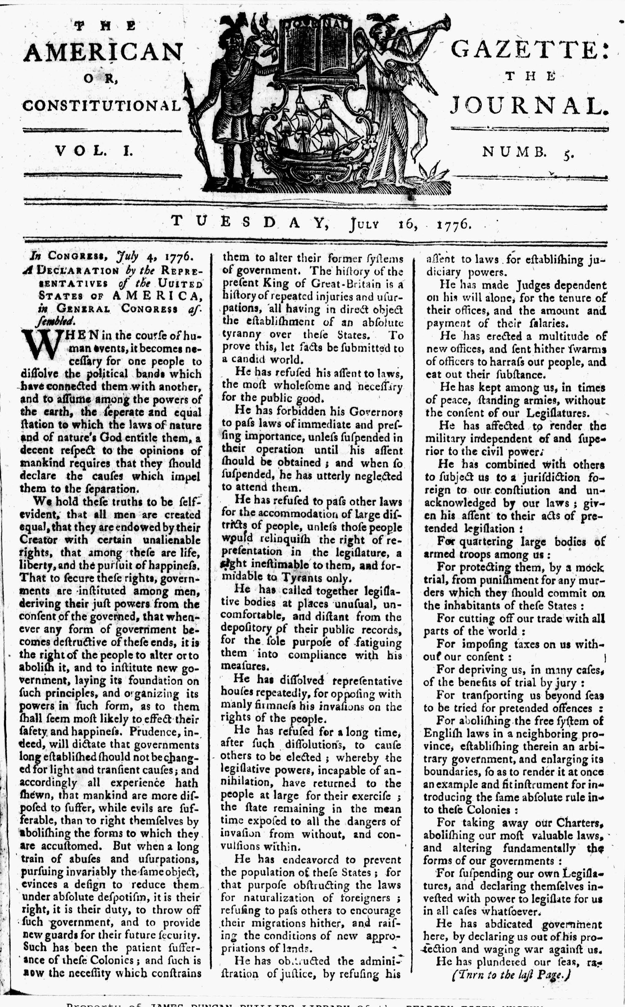
Image Source
“The American Gazette: Or, The Constitutional Journal.” July 16, 1776. Page 1. Image courtesy of Readex: America’s Historical Newspapers. Early American Newspapers, Series 1: From Colonies to Nation.

Document B

Ran away from the Subscriber
(Transcription modified for length and clarity.)
  - This advertisement appeared on the third page of “The American Gazette” on July 16, 1776. Advertisements for escaped and “for sale” enslaved people were common and an important source of revenue for newspaper printers.

Two Dollars Reward
Ran away from the me, on Sunday, the 14th, a Negro man, named Caesar. A thick,
well set fellow, about 25 years-old, about 5 feet 6 inches high. He had on a brown colored jacket, a stripped under-jacket, a pair of brown-colored breeches. His right knee bends inwards.
Whoever shall take up said Negro, and return him to his master, shall receive two dollars reward, and all necessary charges paid by me,
Benjamin Raymond.
Beverly, July 15, 1776

Document B
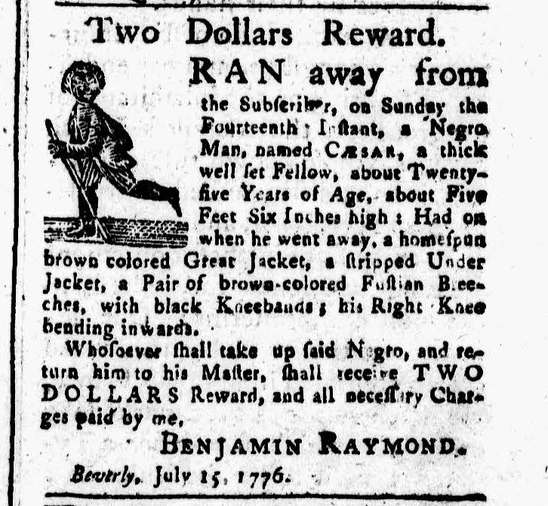

Image Source
“The American Gazette: Or, The Constitutional Journal.” July 16, 1776. Page 1. Courtesy of Readex: America’s Historical Newspapers. Early American Newspapers, Series 1: From Colonies to Nation.

Document B
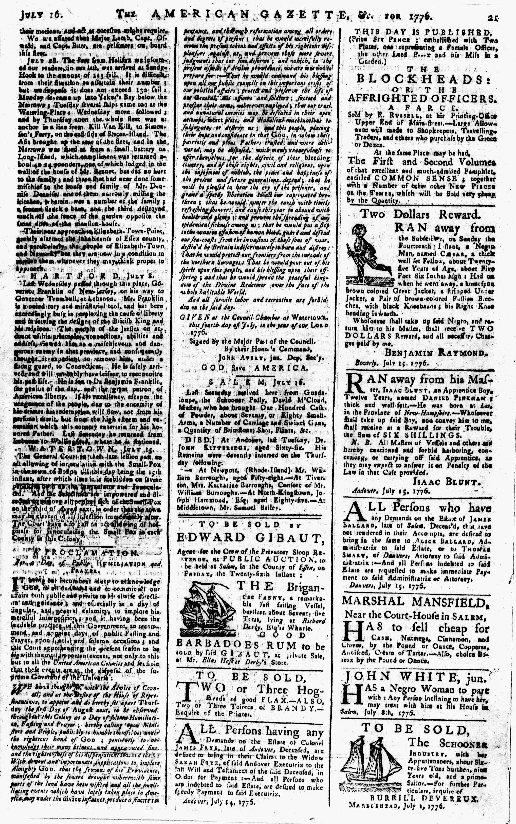
Image Source
“The American Gazette: Or, The Constitutional Journal.” July 16, 1776. Page 3. Image courtesy of Readex: America’s Historical Newspapers. Early American Newspapers, Series 1: From Colonies to Nation.

Graphic Organizer

 | Document A: Declaration of Independence | Document B: Ran Away from the Subscriber
#1
When was this written?

#2
Who was this written by?

#3
Why was this written and printed in the Salem newspaper?

#4
Look back at the transcription. Underline the key points to understanding the document.

Summarize here.

#5
What is happening at the time to help explain this document?

 | Document A: Declaration of Independence | Document B: Ran Away from the Subscriber
#6
Rewrite this document from the point of view of Cesar (mentioned in Document B).

